**EXP NO: 6: 16-BIT SUBTRACTION**  
  
**AIM:**To write an assembly language program to implement 16-bit subtraction using 8085  
processor.  
  
**ALGORITHM:**  
1)   Start the  
program by loading a register pair with address of 1st number.  
2)     Copy the data to another register pair.  
3)      Load the second number to first registre pair.  
4)     Subtract the two register pair contents.  
5)      Check for borrow.  
6)      Store the value of difference and borrow in memory  
locations.  
7)      End.  
  
**PROGRAM:**  
LHLD 2050  
 XCHG  
 LHLD 2052  
MVI C,00

MOV A, E  
  SUB L  
 STA 2054  
MOV A, D  
SUB H  
STA 2055  
 HLT  
  
**INPUT:**

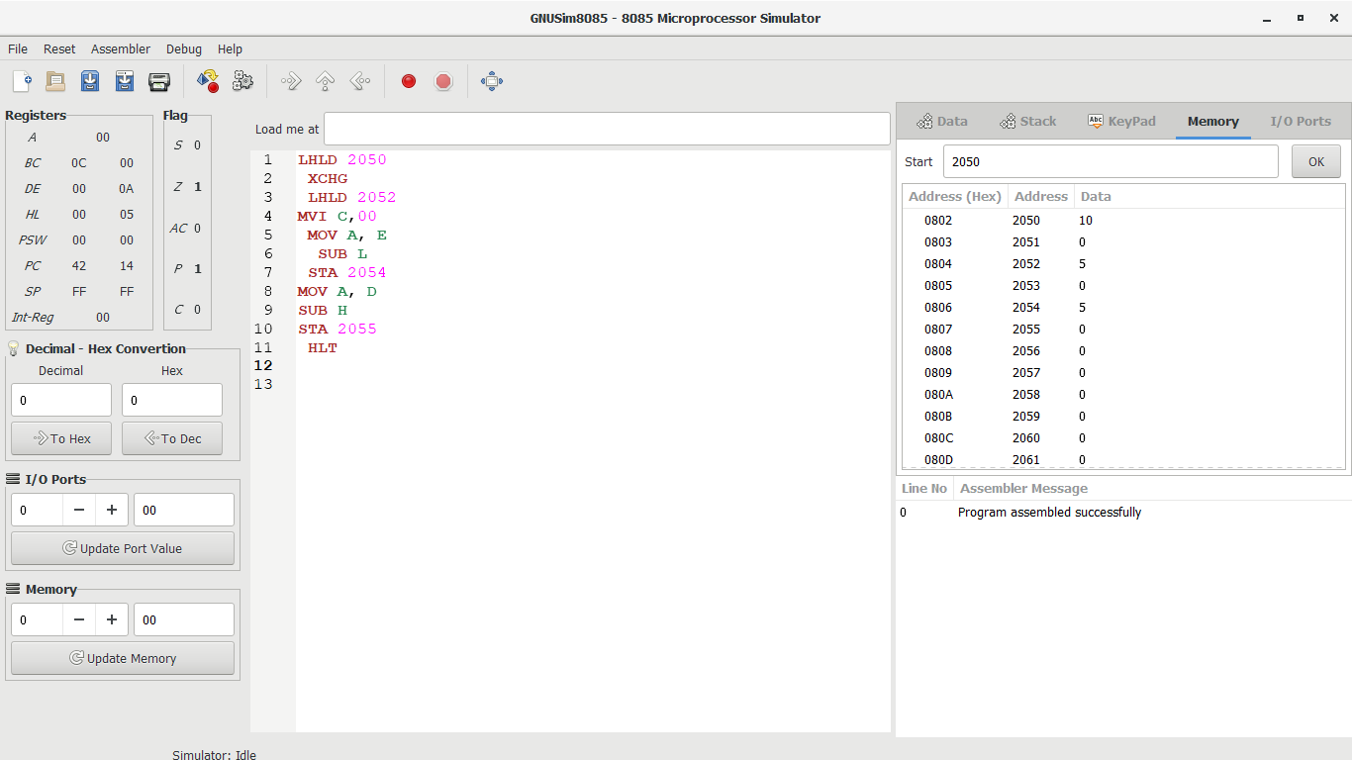

**OUTPUT:**



**RESULT:**Thus the program was executed successfully using 8085  
processor simulator.